2021-2022 21st Century Instructional Initiatives Grants
APPLICATION GUIDELINES
Read carefully to fully understand guidelines and expectations.
Award Range: | Up to $2,000 per project. The number of initiatives funded will depend upon available funds.
Key Criteria &  Eligible Projects: | Review and award of project funds will be based on the project’s anticipated contribution to essential knowledge and skills students must have to be successful in life and employment in the 21st century, clear alignment with the BCPS The Compass: Our Pathway to Excellence and the school progress plan, clear measurable objectives, and overall impact and potential for successful implementation. The 2021-2022 projects should address at least one of the following instructional focused 21st century themes:  Financial, Economic, Business, and Entrepreneurial Literacy Health Literacy  Environmental Literacy Civic Literacy  Arts & Culture Global Awareness  Science, Technology, Engineering, and Mathematics (STEM)  Projects must be conducted and supervised by BCPS professional personnel who work directly with students, including teachers, school counselors, media specialists, nurses, etc. Projects must address an identified need that is aligned with BCPS goals for academics and key actions as stated in the BCPS The Compass: Our Pathway to Excellence and the school progress plans. Funds may not replace normal funding from tax-based sources. The proposal should describe a quantitative and/or qualitative method to evaluate the success of the project. Funds may cover travel, participation in events/activities, consulting fees, and speaker honorariums. Funds may not cover personnel or any related expenses for BCPS staff, including gift cards and food/beverages. If food is purchased for students, it must align with USDA health regulations.
Application Deadline: | On or before Friday, October 22, 2021 by 5 p.m.
Notification of Recipients: | Recipients will receive an e-mail notification from the director on Friday, November 19, 2021, and a media release will be placed on our Web site (https://educationfoundationbcps.org) on Wednesday, November 24, 2021.
Awarding of Funding: | Funds will be disbursed to the school/organization for project expenses according to standard Education Foundation practice as stated on the page titled 2020-2021 21st Century Instructional Initiatives Grants Processing A Request To Disburse Funds From The Foundation Account, (Page 5) using the form titled Request for Reimbursement/ Disbursement from a Foundation Project Fund (Page 6). Any unexpended funds will revert to the Education Foundation unrestricted fund at the conclusion of the project on Friday, May 27, 2022. NOTE: Do not use personal credit cards or cash when making grant purchases.
Length of  Project: | Projects should be implemented during the 2021-2022 school year with all projects to be completed on or before Friday, May 27, 2022, including the request to reimburse/disburse from the foundation project account.
Applicant Eligibility: | Applicants must be BCPS professional personnel. In the case of team-based proposals, a project coordinator must be designated to assume overall administrative responsibility for the instructional initiative grant application, submission of disbursement requests, and any other requested information or reports. Simultaneous funding of projects from the same applicant or benefitting the same classroom, department, or team will not occur.
Proposal Review: | Proposals will be competitively reviewed by the Scholarships and Allocations Committee of the Education Foundation. BCPS curriculum and instruction and/or business services professionals may be consulted as part of the proposal review for the purpose of compliance and alignment.
Initiative Summary: | A project summary is due to the Education Foundation upon the conclusion of the initiative no later than Friday May 27, 2022. See accompanying project summary (Pages 8 and 9) for details. A grant recipient who does not submit a summary will not be eligible for future funding consideration until the summary has been received.

2019-2020 21st Century Instructional Initiatives Grants
APPLICATION COVER SHEET*
Name of Principal or Supervisor : E-mail address:

School/Office: Phone:

Name of Applicant/Project Coordinator: E-mail address:
(Must be BCPS professional personnel)

Is this a team proposal? No Yes (If yes, list team members)

Title of Proposed Project:

Core Subject(s): (May check more than one)
English, Reading and Language Arts History and Culture Studies Government and Civics Arts
Mathematics and Economics Science and Geography World Languages, Early Grades through Grade 12
Physical Education/Health Other
Project aligns with the BCPS The Compass: Our Pathway to Excellence and school progress plan and addresses the following instructional focused 21st century theme(s): (May check more than one)
Financial, Economic, Business, and Entrepreneurial Literacy Health Literacy
Environmental Literacy Civic Literacy
Arts & Culture Global Awareness
Science, Technology, Engineering, and Mathematics (STEM)

Anticipated Date of Implementation:

Anticipated Date of Completion:

Total funds required for project (May include funds from other sources): $

Total funds requested from The Education Foundation of BCPS, Inc. for project: $

NOTE: Application must be completed and submitted electronically on or before Friday, October 22, 2021, by 5 p.m. This cover sheet will not be included as part of the actual selection process by the Scholarships and Allocations Committee. Consideration of your request will be based entirely on the following proposal.

Foundation Headquarters Use Only:

Date Received:

2021-2022 21st Century Instructional Initiatives Grants
APPLICATION PROJECT DESCRIPTION
DIRECTIONS: Respond clearly and specifically to each of the statements/questions below, limiting to a maximum of two (2) typed pages. Do not include the name of your school, administrator and/or teacher in this application project description.
Title of Proposed Project: Grade Level
Core Subject(s): (May check more than one)
English, Reading, and Language Arts History and Culture Studies Government and Civics Arts
Mathematics and Economics Science and Geography World Languages, Early Grades through Grade 12
Physical Education/Health Other
Project aligns with the BCPS The Compass: Our Pathway to Excellence and school progress plan and addresses one or more of the following instructional-focused 21st century theme(s): (May check more than one)
Financial, Economic, Business, and Entrepreneurial Literacy Health Literacy
Environmental Literacy Civic Literacy
Arts & Culture Global Awareness
Science, Technology, Engineering, and Mathematics (STEM)

Implementation Date: Evaluation Date:
Total Amount of Request: Date of Proposal:

- Briefly describe this project and how it will address at least one (or more) of the instructional focused 21st century themes. (10 points)
- Explain how this project meets the goals for academics and key actions as stated in the BCPS BCPS The Compass: Our Pathway to Excellence and your school progress Plan? (15 points)
- What are the clearly defined, obtainable educational outcomes that are measurable of this project and what are the needs it will meet? (20 points)
- Identify and explain the research based instructional methods/techniques and skills that will be implemented through this project. (Learning and Innovation Skills, Information, Media and Technology Skills, and/or Life and Career Skills). Be specific. (20 points)
- What grade level(s) and core subject area(s) will be addressed by this project? Approximately how many students will benefit? What is the potential impact on students and is there a possibility for expansion of this project to other grade levels and/or schools? (10 points)
- List the plan of action including a chronological timeline for academics and key actions in the preparation and implementation of this project. Include: completed lesson plan(s); communication tools and techniques for community outreach; multi-media presentations; ordering/receipting of materials; classroom implementation; evaluation tools; and significant dates, etc. (5 points)
- How will you evaluate whether the objectives for this project have been achieved? (10 points) A project summary is due to the Education Foundation upon the conclusion of the initiative.
NOTE: The enclosed project summary is required at the completion of the project, no later than Friday, May 27, 2022.
- Identify your detailed budget request for this project in order of priority. Include specific information on materials of instruction, equipment, services, and any other fees, charges, and/or payments. If applicable, list funds/resources that will be required to implement this project beyond this grant request. Identify the anticipated source of funds for each expense. Proposed budgets can be revised upon request through the Foundation headquarters. Please list grant in the source column for expenses to be covered by receipt of this Education Foundation award. (10 points)

2021-2022 21st Century Instructional Initiatives Grants
Proposed Budget
ITEM | DESCRIPTION | EXPENSE | SOURCE
TOTAL BUDGET ALL SOURCES |  | $
NOTE: Copies of all original invoices and proof of payments will need to be attached to the Request for Reimbursement/ Disbursement from a Foundation Project Fund (See Attached – Page 6) and the grant summary (pages 8 and 9), and returned to The Education Foundation of Baltimore County Public Schools, Inc., by the end of the 2021-2022 school year in which the initiative is implemented. All reimbursements need to be submitted on or before Friday, May 27, 2022.

Send Electronically To:
Ms. Deborah Phelps, Executive Director Laura Lemon, Associate Director
dphelps@bcps.org llemon2@bcps.org

Self Checklist for Completion of Application
Project is appropriate for submission if the following questions can be answered in the affirmative: | YES | NO
- Project addresses at least one or more of the instructional focused 21st century themes.
- Project meets the goals for academics as stated in the BCPS The Compass: Our Pathway to Excellence /school progress plan.
- Project has clearly defined, attainable educational outcomes that are measurable.
- Project has identified instructional methods/techniques and skills that are research-based and instructionally sound.
- Project has the potential to involve a large number of students with a long-term impact.
- Project plan of action and timeline is clearly stated with realistic attainable dates for completion.
- Project has a built in evaluation component.
- Project includes a detailed budget with items and costs listed.
NOTE: See enclosed Rubric for Instructional Initiatives (Page 7).

PROCESSING A REQUEST TO DISBURSE FUNDS FROM
THE FOUNDATION ACCOUNT

There are two ways that funds may be disbursed from the Education Foundation. One involves the foundation paying for something directly on behalf of the school or project. The other involves the Education Foundation reimbursing the school or project for expenditures they have incurred and paid that relate directly to the Education Foundation project.

- Directly paid by the Education Foundation on behalf of the school/office project.
Certain types of expenditures may be paid directly by the Education Foundation from the project funds. These include large dollar expenditures such as scholarships, technology, or playground equipment, etc.

A written Request for Reimbursement/Disbursement of Project Funds form must be prepared, signed by the appropriate authorized person(s) (e.g., principal, school program plan team chair, project coordinator, or an office supervisor/director), and forwarded with the original invoice and one (1) copy of the invoice order to:

Ms. Deborah Phelps, Executive Director
The Education Foundation of Baltimore County Public Schools, Inc.
105 W. Chesapeake Avenue, Suite B-1
Towson, Maryland 21204

The Education Foundation generally disburses checks twice a month (the 15th and 30th). All requests should adhere to these dates to ensure that items purchased will be received when needed. All disbursement requests are subject to review and approval by the Education Foundation Executive Committee/Full Board.
NOTE: Do not use personal credit cards or cash to pay expenditures. Always use a tax exempt card when making purchases, as the foundation will not reimburse for tax.

- Reimbursed to the School or Organization
Invoices or orders from schools for less than $1,000 should not be sent directly to the Education Foundation to be paid. Small invoices (less than $1,000) should be paid directly by the school/office (e.g., activity funds/procurement cards) and subsequently submitted to the foundation for reimbursement. To request reimbursement, please following these steps:

- Accumulate receipts and prepare a written Request for Reimbursement/Disbursement of Project Funds form that describes each receipt, a description of what was purchased, the amount, the vendor, the total of the reimbursement request, how it is consistent with the goals for academics/objectives of the Education Foundation project, and the Education Foundation project it applies to.
- Forward the request, signed by the appropriate authorized person(s) (e.g., principal, school progress plan team chair, project coordinator, or an office supervisor/director), and the attached receipts to:

Ms. Deborah Phelps, Executive Director
The Education Foundation of Baltimore County Public Schools, Inc.
105 W. Chesapeake Avenue, Suite B-1
Towson, Maryland 21204

- Reimbursement requests will be processed by the foundation twice a month. Accordingly, receipts should be accumulated and submitted on or about the 1st or 15th of the month. Final disbursements are due the last Friday in May.

2011-2022 21st Century Instructional Initiatives Grants
Request for Reimbursement/Disbursement
from a Foundation Project Fund*

Name of Project School/Office
Name of Preparer (Type) Date Phone Number Email Address
Briefly State the Reason/Purpose for the Disbursement:
Amount requested $ Attach original receipts, invoices, quotes, purchase orders, etc. Sales tax will not be reimbursed.
Note: Final disbursements are due by the last Friday in May.
To be paid to (Note: A separate disbursement form must be completed and submitted for each payee):
Name of Business/School/Office to be paid: Phone Number
Address of Business/School/Office to be paid:
All requests for disbursement must be signed by at least two authorized individuals, one being administrator/supervisor in charge.
Name (Type) Title Signature Date
Mail to: Ms. Cindy Whitcomb, Administrative Assistant/Bookkeeper
The Education Foundation of Baltimore County Public Schools, Inc.
105 Chesapeake Ave, Suite B-1
Towson, MD 21204

Foundation Headquarters use only:
Approved by:
Name: Deborah S. Phelps ____ Signature:
Date Paid: Check #: Account #: Amount $

Rubric for 2021-2022 21st Century Instructional Initiatives Grants
Key Criteria | 4 | 3 | 2 | 1 | Score
Need for Project  10 Points | States a need that addresses at least one of the instructional focused 21st century themes.  7-10 points | States a need that somewhat addresses at least one of the instructional focused 21st century themes.  3-6 points | Need stated does not address at least one of the instructional focused 21st century themes.  1-2 points | No reference to need.  0 points | /10
Explanation of How Project Meets Goals  15 Points | Explanation is consistent with goals for academics as stated in BCPS Blueprint 2.0/school progress plan.  11-15 points | Explanation is somewhat consistent with goals for academics as stated in BCPS Blueprint 2.0/school progress plan.  5-10 points | Explanation does not address goals for academics as stated in BCPS Blueprint 2.0/school progress plan.  1-4 points | Does not explain how goals for academics as stated in BCPS Blueprint 2.0/school progress plan will be met.  0 points | /15
Major Objectives of the Project  20 Points | Objectives are clearly defined, attainable, and address the stated needs. Educational outcomes are stated and are measurable.  13-20 points | Objectives are defined and address the stated needs. Educational outcomes are stated.  5-12 points | Objectives are defined. Educational outcomes are not clearly stated and cannot be measured effectively.  1-4 points | Objectives are not clear. No measurable outcomes are included.  0 points | /20
Teaching Methods/ Techniques and Skills to Implement Project  20 Points | Teaching methods/ techniques and skills are research-based and instructionally sound. Project supports goals for academics, strategic initiatives, and key actions, which are clearly stated and identified.  13-20 points | Teaching methods/ techniques and skills are instructionally sound. Project supports goals for academics, strategic initiatives, and key actions, which may not be clearly stated and/or identified.  5-12 points | Teaching methods/ techniques and skills are identified. Project does not support goals for academics, strategic initiatives, and key actions.  1-4 points | Teaching methods/ techniques and skills are not identified and/or no goals for academics, strategic initiatives, and key actions are sited.  0 points | /20
Potential Impact on Students  10 Points | Project has the potential to involve a large number of students with a long-term impact.  7-10 points | Project has the potential to involve a large number of students with some impact.  3-6 points | Project will only impact a few students.  1-2 points | Project does not address potential impact on students.  0 points | /10
Plan of Action / Timeline  5 Points | Plan of action/timeline is clearly stated with realistic dates that are attainable.  4-5 points | Plan of action/timeline is clear with realistic dates that are attainable.  2-3 points | Plan of action/timeline is not clear or is not realistic for successful completion of project.  1 point | Plan of action/timeline is not included.  0 points | /5
Evaluation  10 Points | Evaluation component is built into the project. Methods for evaluating the effectiveness of the project are included and specific evaluation activities are identified.  7-10 points | Evaluation component is built into the project. Methods for evaluating the effectiveness of the project are included.  3-6 points | Evaluation regarding the effectiveness of the project is not specific.  1-2 points | Evaluation is not addressed.  0 points | /10
Budget  10 Points | Detailed budget with items and costs listed.  7-10 points | Detailed budget with items listed and estimated costs on most items.  3-6 points | Budget provide but some items and/or costs incomplete.  1-2 points | Budget is not included.  0 points | /10
 |  |  |  | TOTAL | /100

School Name: ______________________________Twitter Handle: __________________
21st Century INSTRUCTIONAL INTIATIVES GRANT PROJECT SUMMARY
All Instructional Initiative Grant recipients must submit a completed Instructional Initiative Grant Project Summary to The Education Foundation of Baltimore County Public Schools, Inc., along with the Request for Reimbursement/Disbursement from a Foundation Project Fund, including copies of receipts and/or requisition(s).

DIRECTIONS: Provide one or two paragraphs in response to each statement on the summary and insert responses within the designated areas. Artifacts pertaining to the grant implementation, including but not limited to photos, videos, and key stakeholder testimonials (students, teachers, parents, and/or community) should be sent to the foundation for utilization on the foundation’s Web site, in various publications and media releases as evidence of success.
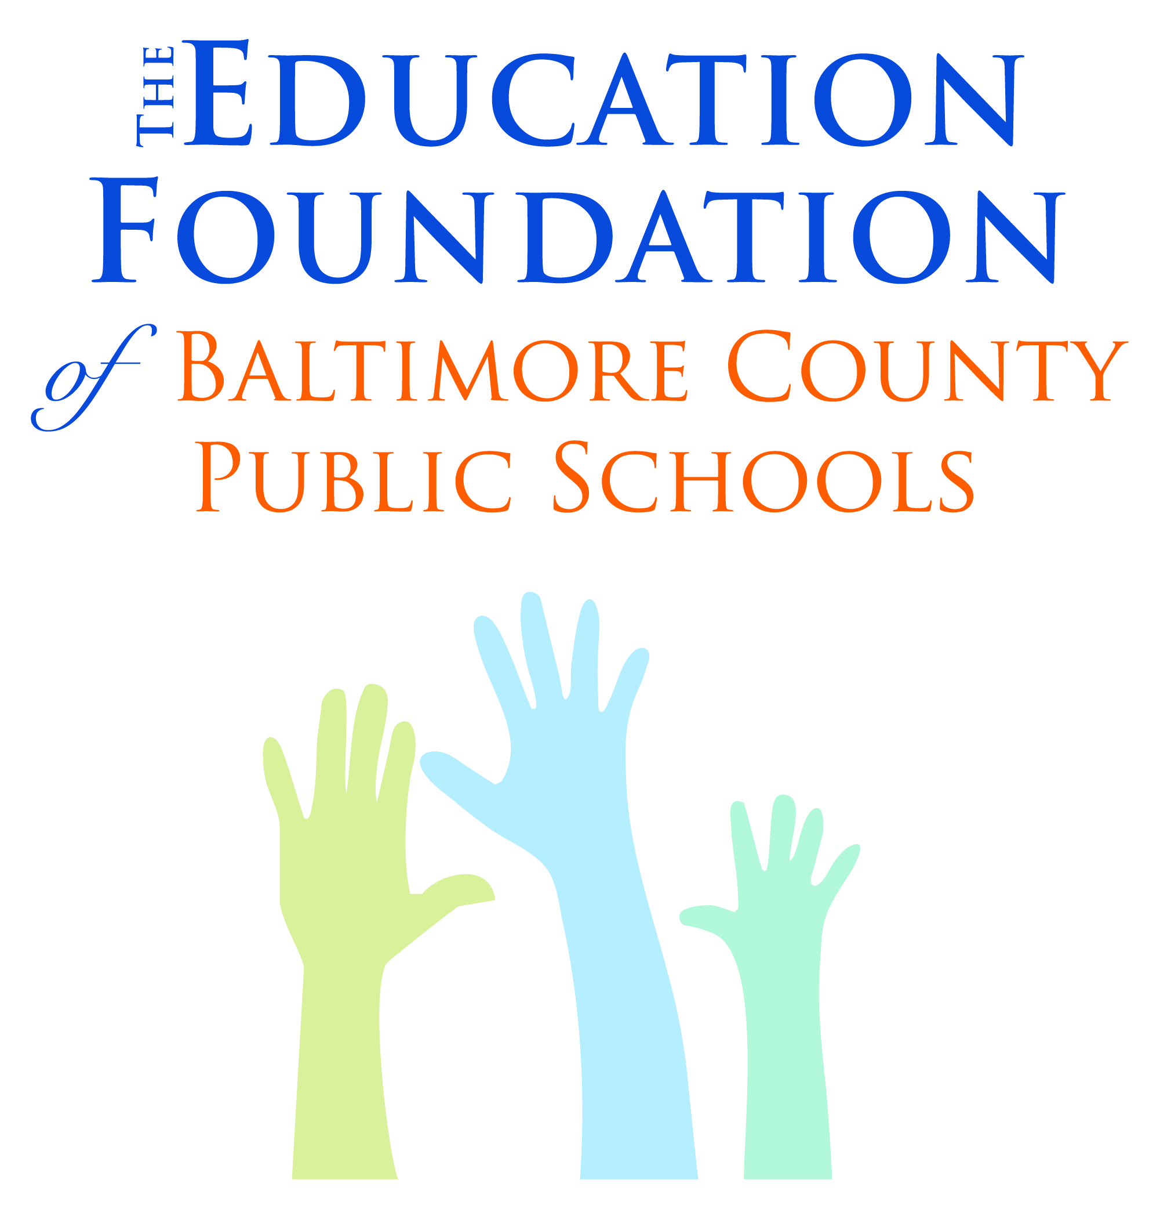
QUESTIONS:
Deborah S. Phelps, Executive Director
dphelps@bcps.org
Or
Laura Lemon, Associate Director
llemon2@bcps.org

DEADLINE:
On or before Friday, May 27, 2022

Title of Grant: _____________________________________________________________

Impact to the following Core Subject(s): (May check more than one.)
English, Reading, and Language Arts History and Culture Studies
Government and Civics Arts Mathematics and Economics
Science and Geography World Languages, Early Grades through Grade 12
Other
Project aligns with the BCPS The Compass: Our Pathway to Excellence and school progress plan and addresses the following instructional focused 21st century theme(s): (May check more than one.)
Financial, Economic, Business, and Entrepreneurial Literacy
Environmental Literacy
Arts & Culture
Science, Technology, Engineering, and Mathematics (STEM)
Health Literacy
Civic Literacy
Global Awareness
Research-based instructional methods/techniques and skills that were implemented through this project. (May check more than one)
Learning and Innovation Skills
Information, Media, and Technology Skills
Life and Career Skills

Implementation Date: Evaluation Date:
Total Amount of Request: Date of Proposal:
Total funds required for project (May include funds from other sources.): $
Total funds requested from The Education Foundation of BCPS, Inc. for project: $

Describe the instructional initiative grant that was implemented at your school including the following:
- How did it impact the core subjects that were identified?
- How did it align with the instructional focused 21st century theme(s)?
- What was accomplished?
- How did it meet the goals for academics, strategic initiatives and key actions as stated in the BCPS The Compass: Our Pathway to Excellence and the school progress plan.

Indicate the grade level and number of students who benefited from the instructional initiative grant and if it impacted student learning, student attendance, and/or student behavior, including character development. (Complete boxes below that are pertinent to the impact of the grant at your school. May check more than one.)

Grade Level(s): Number of Students:
Student Learning: Student Attendance: Student Behavior:

Explain the evaluation method used to measure the effectiveness of the instructional initiative grant and the results, pertaining to student learning, student attendance, and student behavior, including character development.

Explain what you would change about the implementation and/or evaluation of the instructional initiative grant.

Did you showcase the instructional initiative grant within your school/within your community? Yes/No? How?
Within your school: Yes No
Explain:

Within your community: Yes No
Explain:

Will you apply during the 2021-2022 instructional initiative grant?
Yes: No:

NOTE: To be eligible for future funding, all grant recipients need to submit this project summary.

DIRECTOR’s REQUEST:
Take a photo of your 2021-2022 Instructional Initiatives Grant initiatives for Storyboards
and submit to
Debbie Phelps, dphelps@bcps.org and Laura Lemon, llemon2@bcps.org

Ms. Deborah Phelps, Executive Director
The Education Foundation of Baltimore County Public Schools, Inc.
105 W. Chesapeake Avenue, Suite B-1
Towson, Maryland 21204
443.809.8962

.

